Website and Email Admin Instructions

- Purpose
This document provides a step-by-step overview of key administrative tasks which are needed to support IBR’s website - http://indianabulldogrescue.com – as email.
Trackabeast is also included in this document in a separate section.
- Key Contacts
IBR’s website was designed and is supported by Anderson Creative. The have full administrative access to our site and we pay a monthly fee for hosting and support. So, if there are any, you can always reach out to Arin Anderson and she will be happy to help. Her contact information is: Arin Anderson. Anderson Creative, LLC. arin@andersoncreative.works 317.813.9597
- Website and Email Background
IBR’s website was implemented in May 2016 by Anderson Creative. It is a WordPress based site and is hosted by a company called Flywheel (https://getflywheel.com/). Several supported WordPress plug-ins are used to drive necessary functionality, the most notable of which is Ninja Forms (https://ninjaforms.com/) which is the back-end for all of the forms (applications, surrender, volunteer, etc.) on the website.
The website is hosted separately from email. IBR’s email is hosted by GMail.
- Bookmarks
In order to best support IBR’s website, it is suggested that you set-up an IBR folder in your browser of choice and bookmark the following pages:
Website Admin
https://indianabulldogrescue.com/wp-admin/ (log into IBR email first and click Login with Google at top)
Google Admin console - https://accounts.google.com/signin/v2/sl/pwd?continue=https%3A%2F%2Fadmin.google.com%2Findianabulldogrescue.com%2FDashboard%3Fpli%3D1%26fral%3D1&service=CPanel&skipvpage=true&passive=3600&authuser=0&flowName=GlifWebSignIn&flowEntry=ServiceLogin
Main site - https://indianabulldogrescue.com/
Foster dogs - https://indianabulldogrescue.com/ibr-foster-dogs/
Volunteer page - https://indianabulldogrescue.com/volunteer-forms/#

- Create a new Foster Dog Bios
Keeping the bios for IBR’s (awesome!) foster dogs up-to-date is most critical administrative task associated with supporting the website. Foster dog bios can be seen here - https://indianabulldogrescue.com/ibr-foster-dogs/
When a new intake comes in, the website admin needs to post a bio within 2 to 3 business days of intake. The process for posting a bio is as follows:
- Before you access the website to post the bio, you will want to do the following:
  - Download photos of the dog from the IBR Volunteer Page on FB.
    - I have created a separate folder on my computer for IBR photos so that I can easily save and then access them for uploading to WordPress.
    - I used the foster dog’s name as the filename in order to make these easier to search/find on my computer and in WordPress.
  - Collect as much information as you can about the dog to include in the initial bio – type of pull (shelter/owner surrender), intake date, age, weight, general temperament, etc. You can also collect this information from the Surrender Form. See Section I.

- When you are ready to post the dog’s bio, you will need a access the admin login link - https://indianabulldogrescue.com/wp-admin/ . Ensure you are logged into your IBR email account first and then click “Login with Google” at the top.

- Once in the Admin, access Posts on the left navigation.

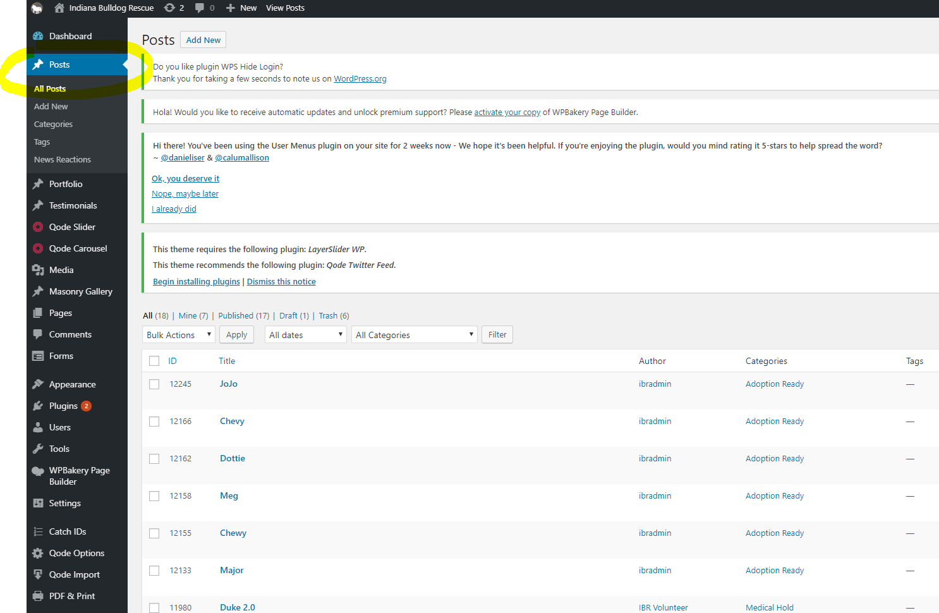

- Pick a bio – Medical Hold is easiest – from the list, hover over it and select “Duplicate Post”
- Hover over copied post and select “Edit Post”

- Update dog’s name in title and permalink
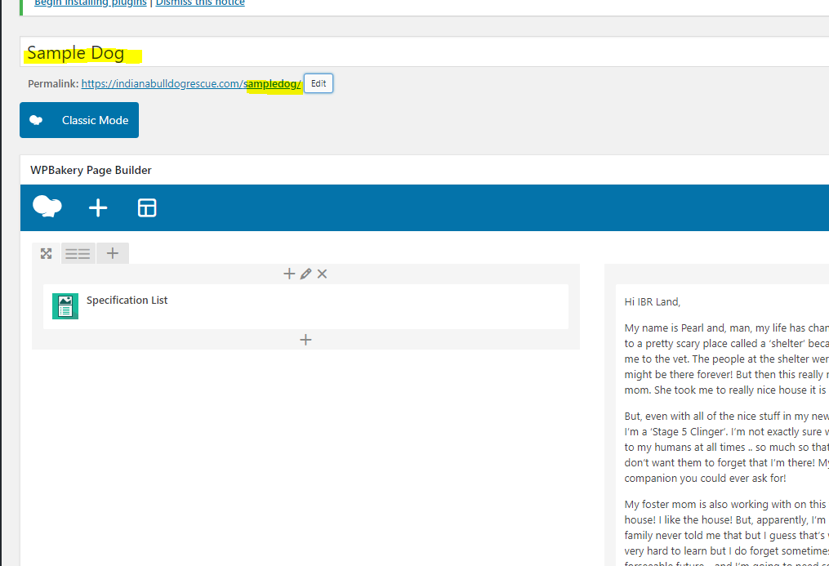

- Hover cursor over Specifications List box and a green command strip will appear. Select the pencil in the middle and the Specifications List will pop up. Edit all specifications to match new dog. 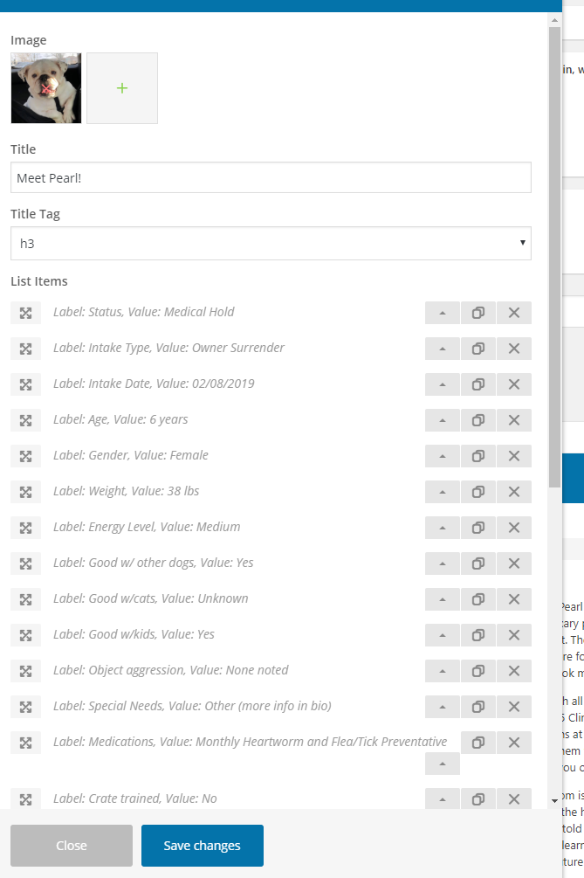
- Remove the copied photo at top. Select plus sign and follow prompts to upload photo(s) of the new dog. Note: I upload all photos of the dog in this step just to make things quicker.
- Select the best photo to show here as main photo on the dog’s bio.
- When done with specification updates, click “Save Changes”.

- Update Bio, Image Gallery and Category. For Bio and Image Gallery, hover over section, select pencil, make edits and then select Save. For Categories, select the checkbox to match the appropriate status for the dog.

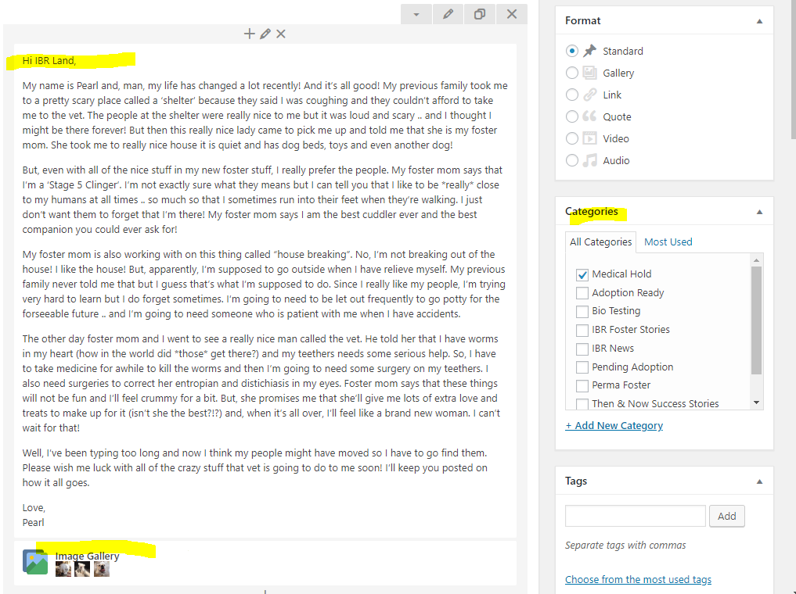

- Update excerpt and featured image. For excerpt, just click in box and update all content. For featured image, just click on the image and you will be taken to the gallery where you can pick the best image (same image as you picked in specifications header).
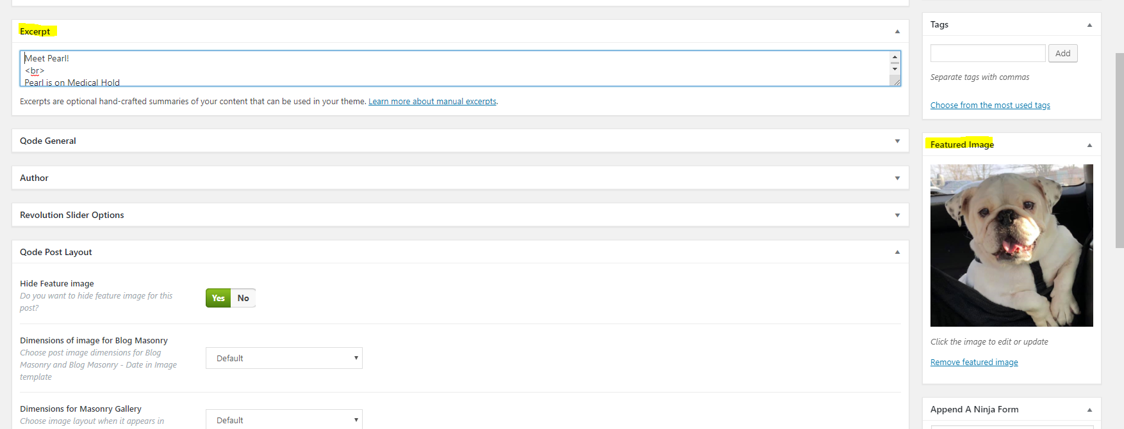

- In Post Layout selection, review the following:
  - Hide Feature Image should always be set to Yes
  - Posts on live site are ordered first be Featured Post and then by Public date. So, you can set the Featured Post to Yes if you want the post at the top of the list or no if you want it farther down. I typically set it to No for Medical Hold dogs and Yes for Adoption Ready.
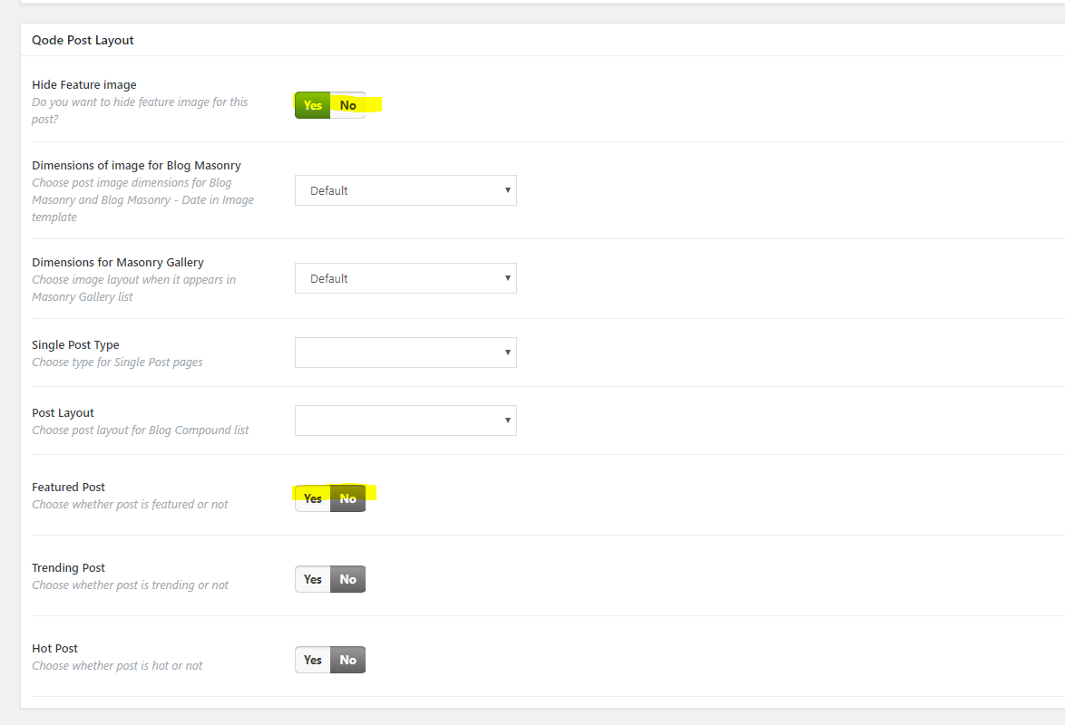
- Once done, scroll to the top and click on the blue Publish button. You can also edit the Publish date manually here if needed to reorder posts on the live site.
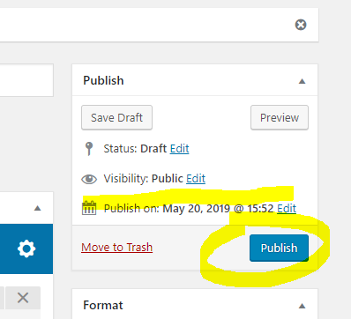

.

- Performing Admin Updates to Bios
Foster parents will often forget to update bios when their foster dogs go on trials and/or are adopted. So, you will need to keep your eye out on the Volunteer FB page for these updates and then ensure they are posted on the website. Some examples:
- When a foster dog goes on a trial, the Category and adoption status in the Specification List, Bio Text Box and Excerpt sections change to Pending Adoption.
- When a foster dog is adopted, you can change the Post Status from Published to Draft and this will remove the bio from the website.

- View Form Submissions
As noted in Section C, Ninja Forms drive a lot of the interactive content on IBR’s website. This includes surrender forms, adoption applications, volunteer applications and volunteer forms. Occasionally, volunteers will report that forms were submitted but emails were not received.
- Select “Forms” from the left hand navigation.
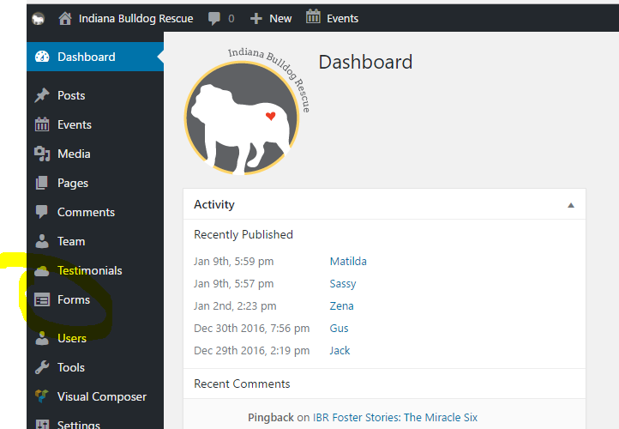

- Then click on Submissions and select the type of Form for which you want to view submissions and the list of submitted items will appear. You can scroll over any item and select “edit” to view the contents.
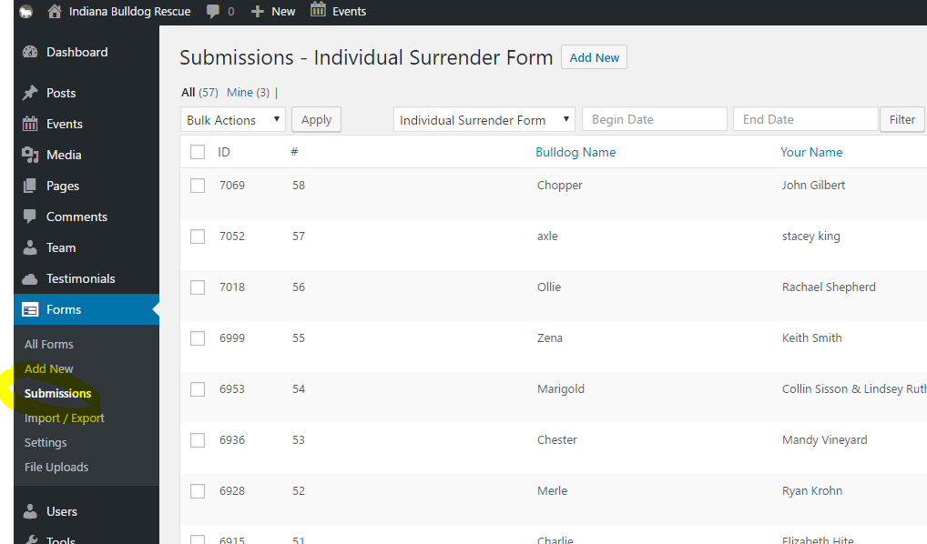
- If the issue reported is a submitted form without an email receipt and you can’t find any viable reason why the email didn’t go through, you can do the following:
  - Print the submission to PDF from the back-end and send it to the volunteer so that they have it.
  - Submit a test form from the website to see if the email issue persists.

- If you ever need to contact Ninja Forms for support, you can do so by logging in at https://ninjaforms.com/your-account/ Login is morroje / !IBR2017

- Edit Forms
If you need to edit a form, then access Forms via left navigation (same as pervious item), then select All Forms. Find the necessary form, hover over it and select edit. The “Build your Form” tab contains all of the form field. The “Email & Actions” tab contains all of the details of what occurs after the form is submitted.

- Edit Website Pages
If you need to edit a page on the website, just select Pages from the left navigation. Find the page you want to edit, hover over it and select edit. Once in the page, find the section to edit, hover and click pencil. Make changes, save and then select publish.

Trackabeast Admin Details

- Key Contacts
Carrie Gerendasy created and supports Trackabeast. She can be reached at carriedasy@comcast.net.
- Maintaining Dogs in Trackabeast
Details on maintaining dogs in Trackabeast are contained in the IBR Foster Procedures document. This document focuses solely on admin updates.
- Adding New Foster Family or Vet to Trackabeast
When a new foster family or vet is approved, you will need to add them to Trackabeast. To do this, you will need to:
- Login to TB with your admin credentials
- Select People Tab and then Add New Person
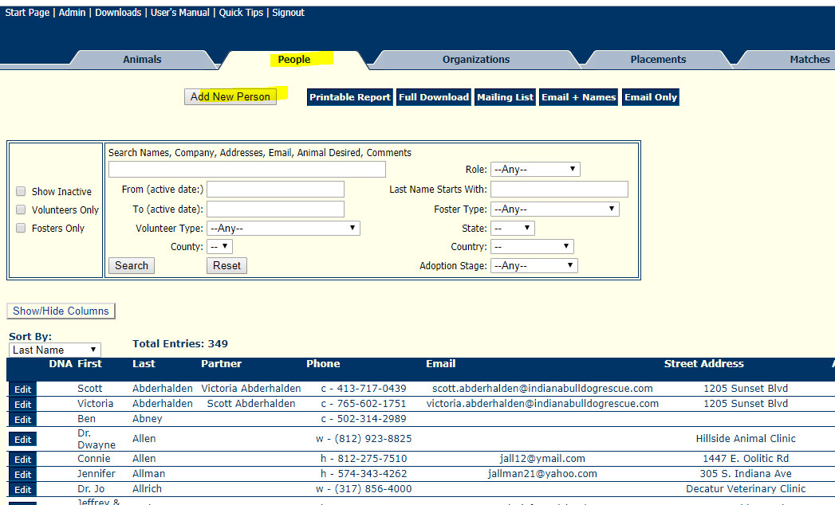

- Fill out pop up box. For a foster, select Foster and System User boxes. For Vet, only select Veterinarian box. Select submit.
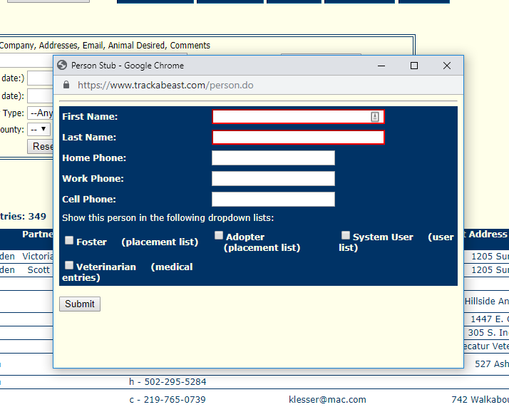

- Fill key contact information. For a foster, you can obtain the PDF foster app from the Foster team and upload it via Manage Files at the top. Click Submit.
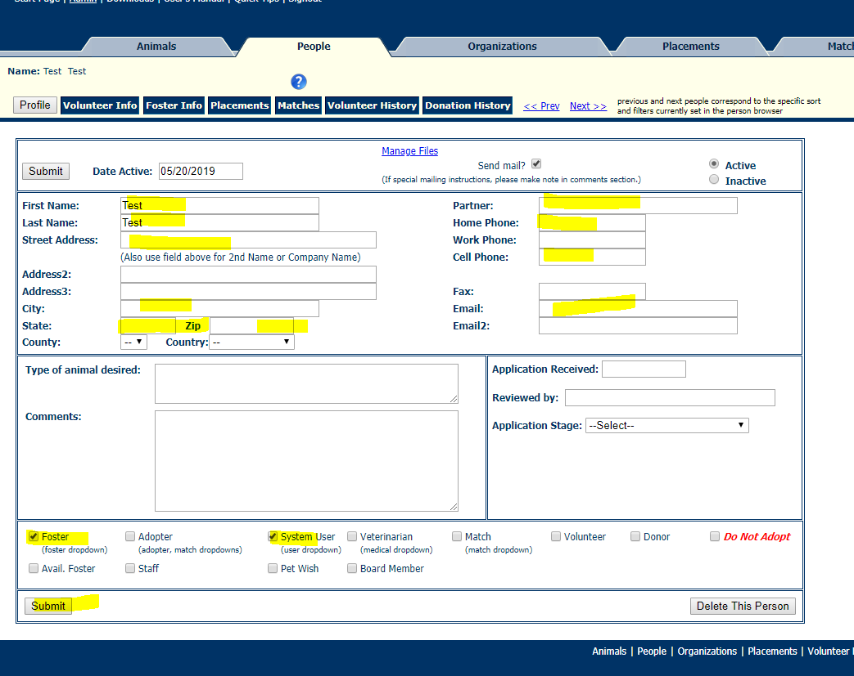

- For Foster, you will now need to go to Admin via the top navigation and add them as a user by selecting them from the first drop down box.
  - User name is First.Last and password is IBRbulldogs2017.
  - Access for fosters is “Read-Write (Current Fosters Only)”
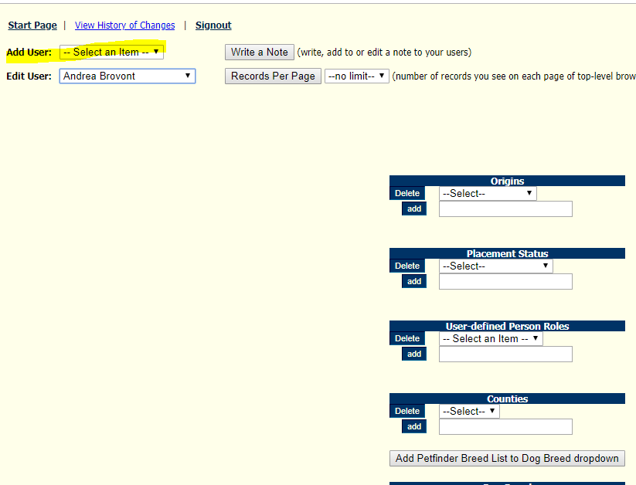

- Adding New Foster Dog to Trackabeast
When adding a new Foster Dog to TB, you will want to ensure that their foster family is entered first. Once this is confirmed, then:
- Go to Animals tab and select Add Dog
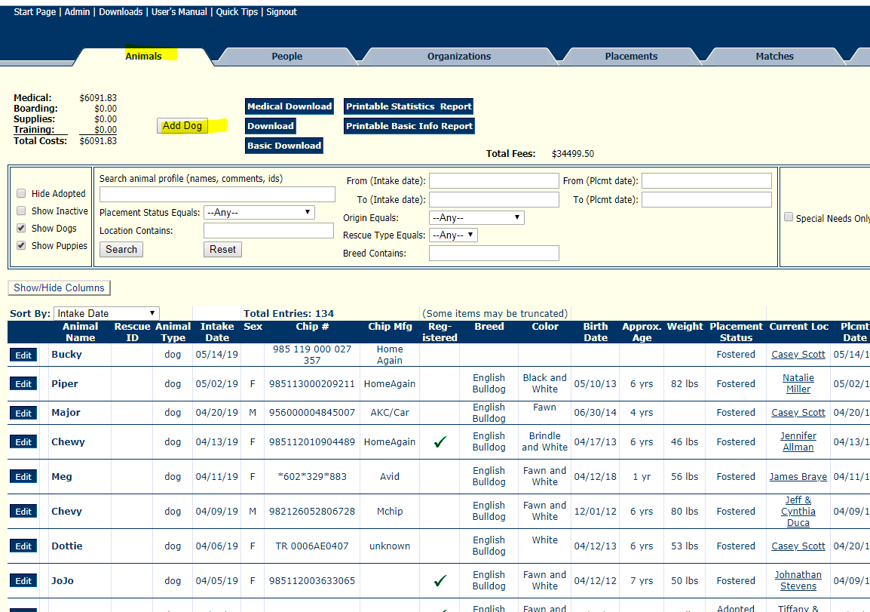
- Fill out all information and add photo/
  - NOTE: Special need info appears on the printable medical record that is provided to adopters. Description/temperament does not.
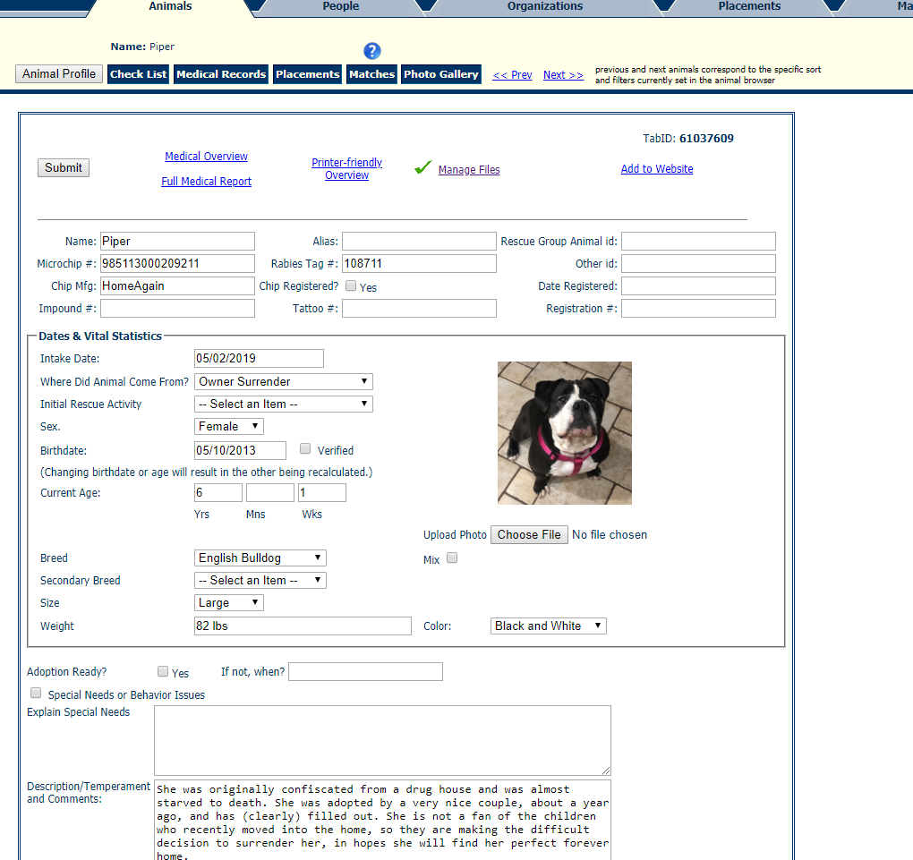
- Upload PDF surrender form from Surrender Request email via Manage Files.
- Then click Submit to save all information on the dog.
- Next click Placements at the top and select Add New Placement. Select intake date. Placement Status (Fostered) and foster name from drop downs. Click submit to save changes.
